STEP 1: PYTHON INSTALLATION

* Python 3.8 should be installed initially. Download python3.8 (preferred 3..8.10) exe file from the official website. Added link in below and this may change based on their site maintanence

link : https://www.python.org/downloads/release/python-3810/

* double tap to click install and check add python 3.8 add to path and click Install Now. Now click install for all users and continue steps further.

* Note down the path of installing while installing. This path should be used during the environment variable setup
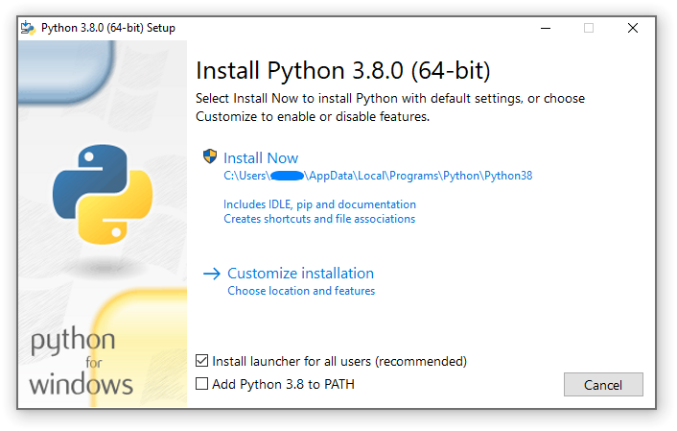

* To check whether it is installed or not, open command prompt and type below to validate

~$ python3 –version
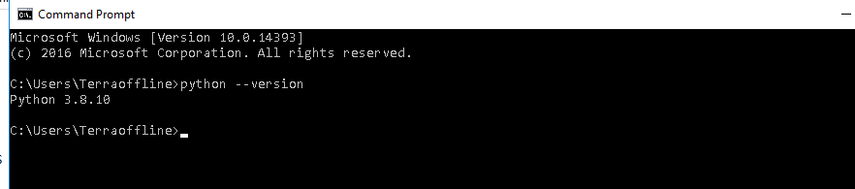

* If you get errors, try adding path’s manually to windows environment variables. For this you’ve to find the python installation path in C drive.

Go to --> mycomputer -right click --> properties --> advanced system settings --> environment variables --> system variables

1) In system variables click on path and add the path you’ve installed python & Scripts folder

ex : C:\Users\Terraoffline\AppData\Local\Programs\Python\Python38
C:\Users\Terraoffline\AppData\Local\Programs\Python\Python38\Scripts

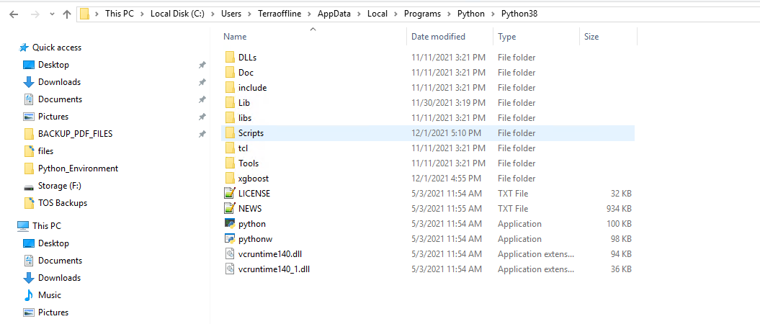
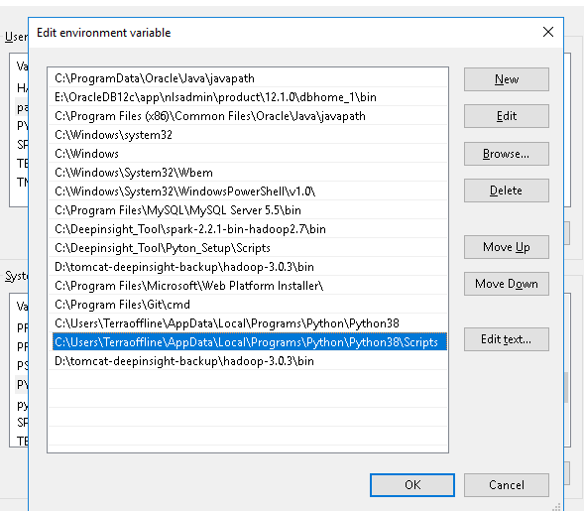

In environment variable click new and add python installed source path as python path
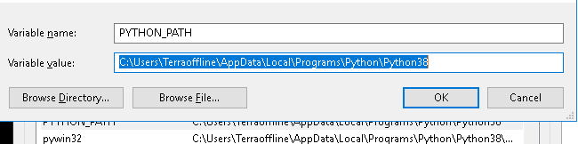
add one more variable, In python source path you may find Scripts folder add that folder as PIP_PATH
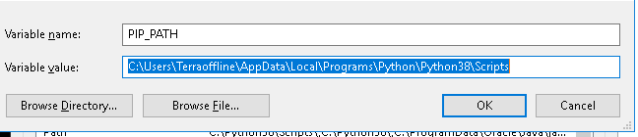

Save and do check now. You may able to get the python version in cmd.

STEP 2: INSTALL MICROSOFT VISUAL C++ 14.X STANDALONE

* To install the above we need to install Build tools for visual studio

Link : https://visualstudio.microsoft.com/downloads/

* Using the above link redirect to download page and in the bottom search for build tools. Download the second one Build Tools for Visual Studio 2022

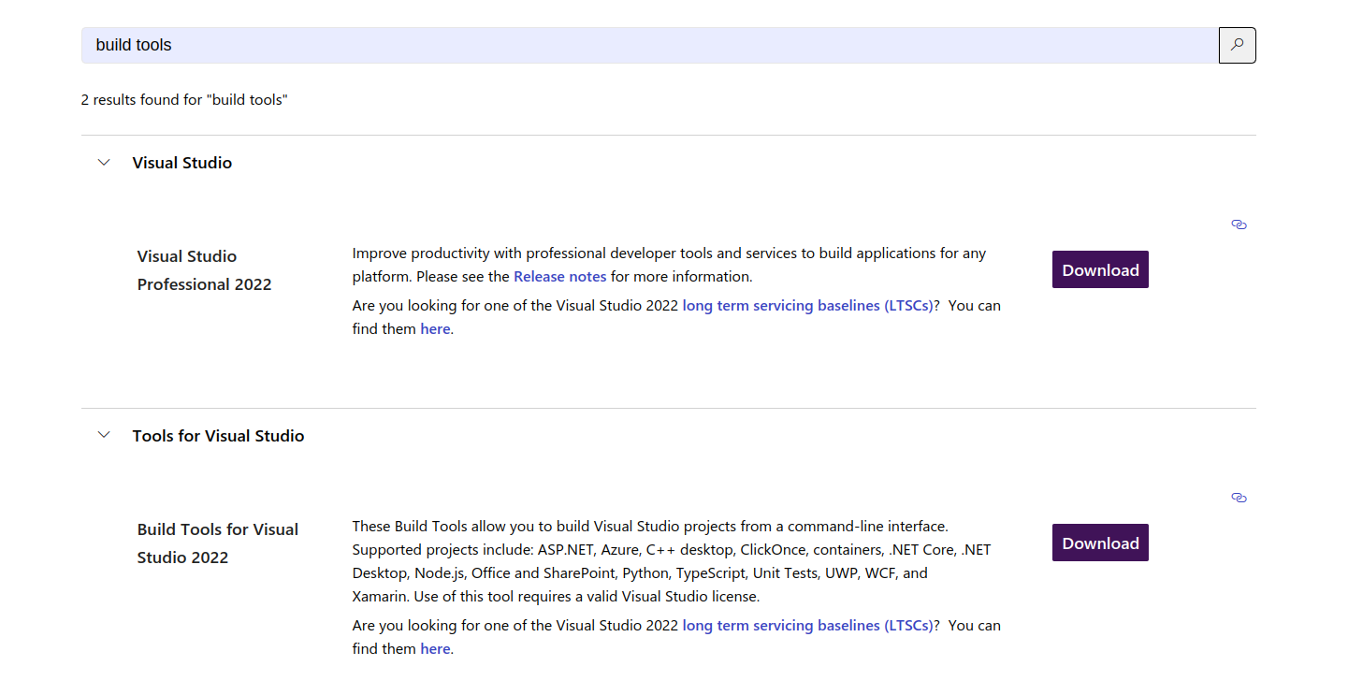

* Go to downloaded folder and double tab to run the application. It will download some internal files and automatically gets installed
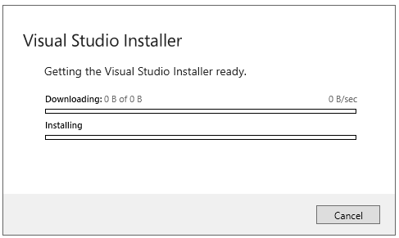

* after downloading you’ll be landed to below page. In that select individual components and select the components in right side of image and Install it.

Required Components
* .NET Framework 4.8 SDK (Choose the latest version)
* .NET Framework 4.7.2 targeting pack (Choose the latest version)
* Windows 10 SDK (Choose the latest version)
* MSVC V143 - VS 2022 C++ x64/x86 build tools (latest) (Here V143 is latest choose the latest while you’re installing)
* C++/CLI Support for v143 build tools latest (latest)
(Note : The below componet versions are latest while installing. Choose whichever is latest while installing)
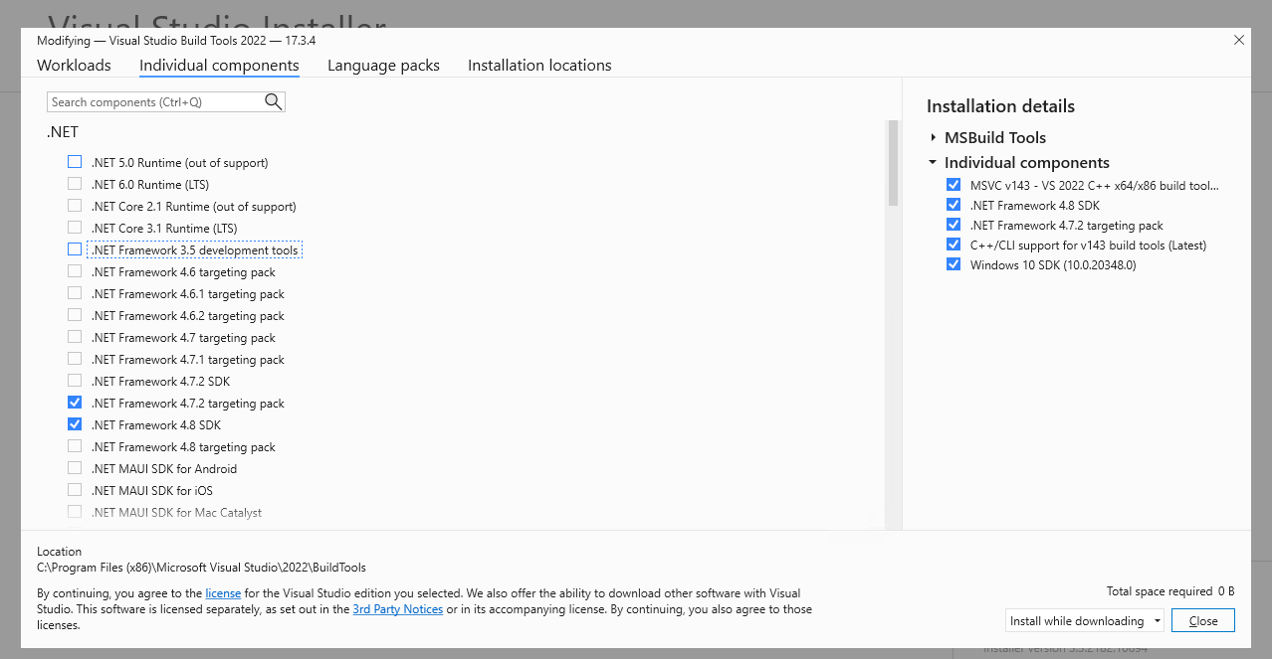

* After installation close it.The above process may required Internet connectivity and some space from C drive

STEP 3: FOLDER STRUCTURE

* To create the folder structure go to the respective path you’ve allocated for installation and create a following directory

*Python_Dependencies *Python_Environments
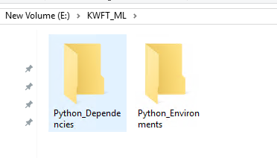

STEP 4: GIT TERMINAL SETUP

* Download the git terminal using below link and do install it. Do search for Git Bash and open the terminal

Link : https://git-scm.com/downloads
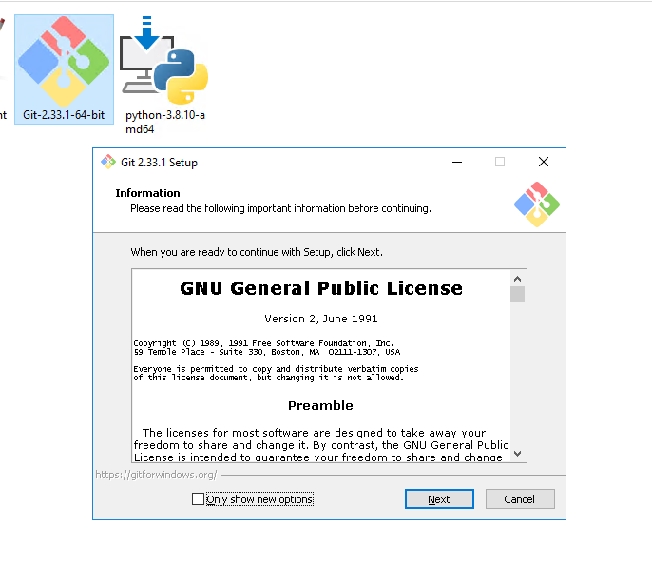
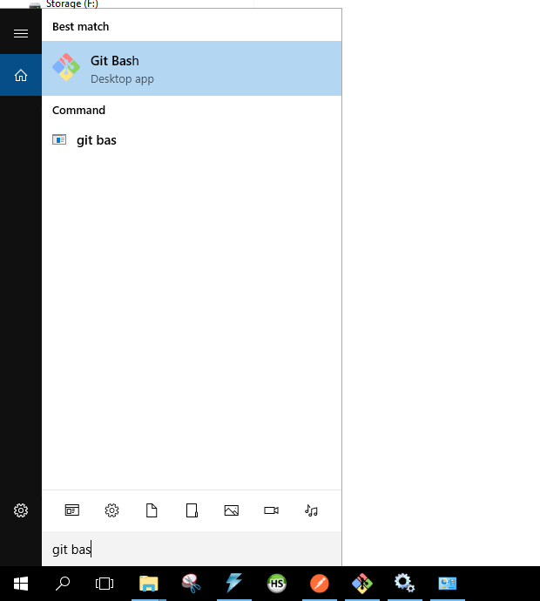

STEP 5: ENVIRONMENT SETUP (METHOD 1 – ONLINE (PREFERRED))

* Create the virtual environment and install necessory libraries to the respective enviroment. To create the virtual environmet,first to install virtual environment setup

~$ pip install virtualenv

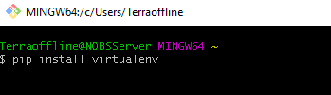

and followed by to create the virtual environment in Python_Environment folder we’ve created. Navigate to python environment folder using below command

~$ cd E:KWFT_ML/Python_Environments/

and to install python environment

~$ virtualenv -p python superset

here navigated to Python_Environments path for installing python environment and superset is the environment name

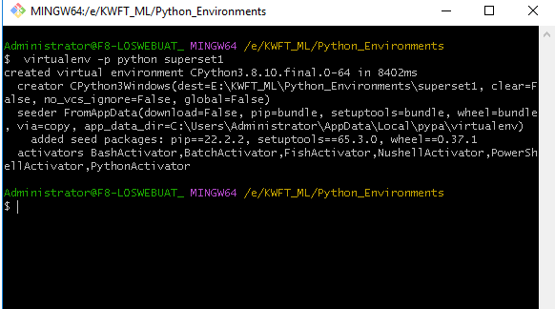

once the environment installed you may find the folder in the respective path you’ve mentioned

* To activate the created python environment

~$ source superset/Scripts/activate

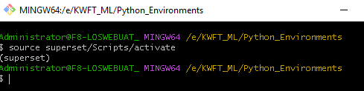

Here we navigated to python environment directory and then /Scripts/activate will activate your environment. you may find the environment name in terminal

* To install the dependencies paste the given requirements.txt file Python_Environment folder and to install the depedencies using below

~$ pip install -r requirement/requirements.txt

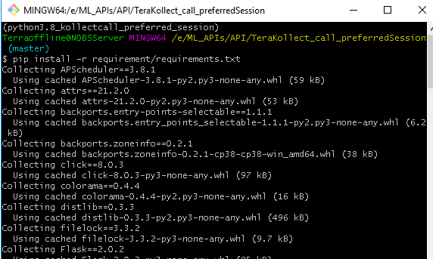

it will take some time based on the libraries we’ve used

STEP 5: ENVIRONMENT SETUP (METHOD 2 – OFFLINE)

* In this method required libraries dowloaded from the other system and later it’s been moved into required system. To dowload first you need requirement.txt file. Create a folder for libraries to download and paste the requirement.txt file outside the folder directory
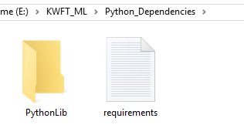

* To install the required libraries in specied folder

~$ pip download --destination-directory PythonLib/ -r requirements.txt

Now you may able to see the required libraries downloading in the specified folder. Copy the folder and requirements.txt file to the destination system.

In Python Depedencies folder paste the below files given and do extract the ZIP file. Create req.txt file which holdes virtualenv txt inside it. The folder structure should like below.

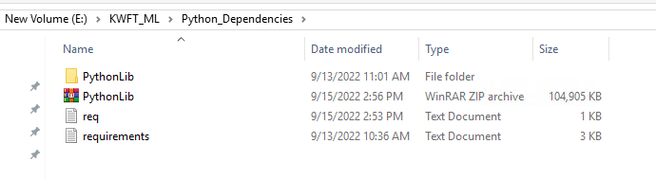
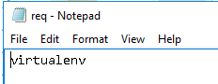

* Nagaviate to Python dependencies folder and run below

To Nagaviate

~$ cd E:/
~$ cd KWFT_ML/Python_Dependencies/

To Install the Virtual enviroment

~$ pip install --no-index --find-links=PythonLib/ -r req.txt

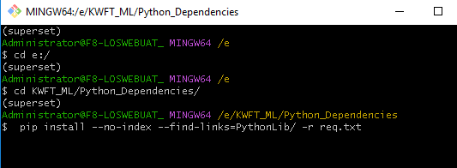

and followed by to create the virtual environment in Python_Environment folder we’ve created. Navigate to python environment folder using below command

~$ cd E:KWFT_ML/Python_Environments/

and to install python environment

~$ virtualenv -p python superset

here navigated to Python_Environments path for installing python environment and superset is the environment name

once the environment installed you may find the folder in the respective path you’ve mentioned

* To activate the created python environment

~$ source superset/Scripts/activate

Here we navigated to python environment directory and then /Scripts/activate will activate your environment. you may find the environment name in terminal

* To install the dependencies paste the given requirements.txt file Python_Environment folder and to install the depedencies using below

~$ pip install -r requirement/requirements.txt

it will take some time based on the libraries we’ve used

STEP 6: SUPERSET SETUP

* Superset already been installed via requirements.txt. Now we need to setup to use it further.

Nagaviate to Superset environment first
~$ cd E:KWFT_ML/Python_Environments/superset/Scripts

To create Flask app
~$ export FLASK_APP=superset

To Initialize the database
~$ superset db upgrade

Load some data to play with
~$ superset load_examples

Create default role and permissions
~$ superset init

STEP 7: DATABASE PREREQUISITES
* Superset using its own data to all configurations in it. It stores all data in a file. This file needs to be changed so our chart changes will reflects here. To change this file go to

C drive -> Users -> Select the user you’ve installed (Administrator) and .superset
(If not found then click show hidden files to see)

* Replace the given file named superset in that filder (don’t change the file name)

To Re Initialize the database
~$ superset db upgrade

To Run the application
~$ nohup superset run -p 8088 --with-threads --reload --debugger &
~$ logout

STEP 8: VALIDATE APPLICATION RUNNING OR NOT

* once above steps are completed you may check whether application working or not using below URL
URL : http://127.0.0.1:8088/

You will redirected to login page. To login superset
Username : admin
Password : Admin@321

STEP 9: DATABASE CONFIGURATION

* In further Database needs to be configured to further charts to access the database

Login to Superset -> Data -> Databases -> right side tope corner new database -> select the respective database you’re configuring
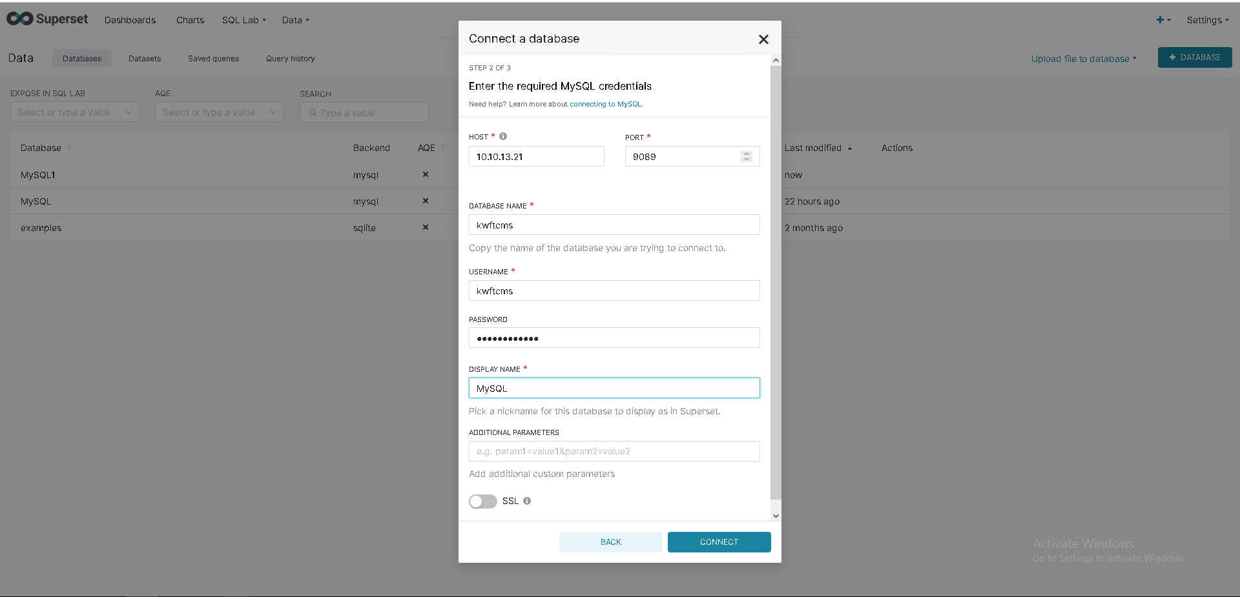

Enter the Hostname,Port,Database,Username,Password and Connection name as MYSQL and connect

Now you may able to visualise the chart as per the Given URL for Dashbords

Ex : http://127.0.0.1:8088/superset/dashboard/14/

* STEP 10 : FURTHER VERSION’S DEPLOYMENT

In the above we’ve seen how to deploy the fresh version.here quickly brief how to deploy the next and further releases

* Replace the given superset file in specified folder
* Do login and check the connection details
* Activate the respective python environment using above commands
* Run the superset using above commands

* First step to terminate the process we’ve executed already in past. We’re running our application in port no 8088 and going to kill our process using port number. To do that in cmd

~$ netstat -ano | findstr :8088
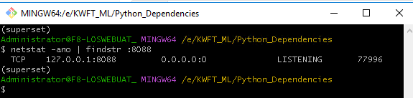

and using the above PID (77996) we have to kill the process. (Some times it may show multiple PID we have to kill all). To double check execute the cmd again and again till it is empty

To kill the PID

~$ taskkill //PID 77996 //F

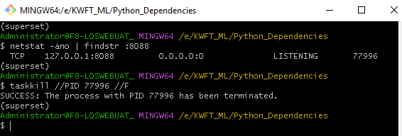

Replace the Superset file given in the above specified folder

To Run our application again

Nagaviate to Superset environment first
~$ cd E:KWFT_ML/Python_Environments/superset/Scripts

activate the environment
~$ source activate

To create Flask app
~$ export FLASK_APP=superset

To run
~$ nohup superset run -p 8088 --with-threads –reload --debugger &

and type

~$ logout

and close terminal and execute the process in background

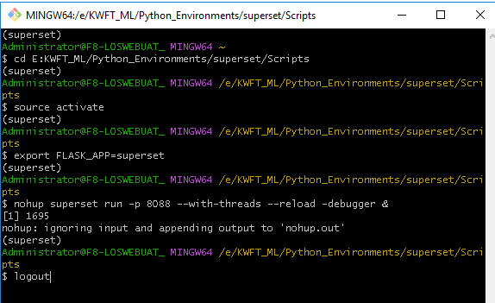
and this need’s to be validated further, whether the application running or not using the above methods mentioned

